

CIS C290

M04 Assignment: Regression Analyses

Part 1. Using the student_performance.csv file, run simple linear regression on the student ‘performance-outcome’ based on ‘hours_studied’ and write 3-4 sentences describing the data results. Include a screenshot of the Python output.

Based on the data results, the linear equation that fits the model is approximately (y = 2.77x + 41.38). This suggests that the students within the dataset almost always have a basic understanding of the course in question that they are able to score 40% without studying. This also suggests that for every hour of study, the students on average scores about 3% higher. However, this test cannot confirm nor deny the association that studying is the only factor in the student’s performance.
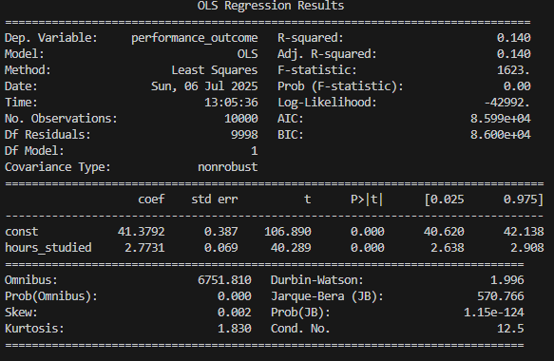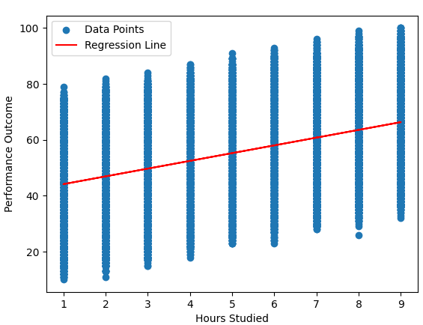

Part 2. Using the student_performance.csv file, run a multiple linear regression on the student ‘performance-outcome’ based on all the variables in the dataset and write 3-4 sentences describing the data results. Include a screenshot of the Python output.

Based on the data results, the multiple linear equation that fits the model is approximately (performance_outcome = 2.85 hours_studied + previous_scores + 0.48 sleep_hours + 0.2 sample_questions_practiced – 33.76). Since the p-value for all of the predictor variables are 0, this suggests that the model is accurate and all variables are impactful. One thing to note is that the constant is a negative number due to the model’s fit, since it is impossible for a student to score a negative points.

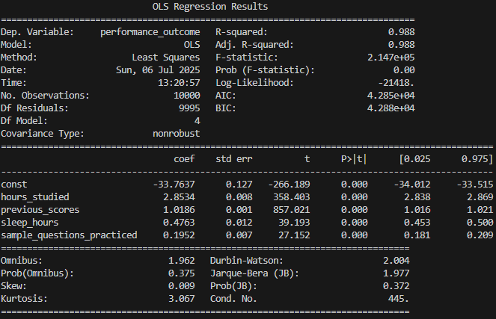

Part 3 FOR PRACTICE. Using the student_performance.csv file, run a regression model of your choice that fits continuous data. Challenge yourself to split the data with a 70/30 training/testing spilt and assess the model performance. Write 2-3 sentences describing the data results. Include a screenshot of the Python output.

Based on the Polynomial Regression model, the mean squared error and r-squared error both suggest that the model is closely fit to the actual data. After the model has been trained, the conducted prediction based on the test values seems accurate with the few presented on the output all have less than 4 points of difference from the actual score the student preformed.
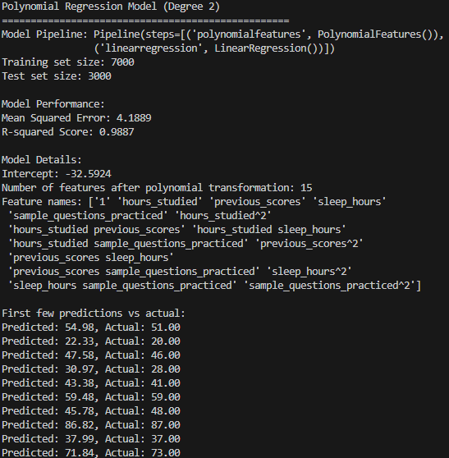

Part 4. In a minimum of 3 sentences, describe your experience with the assignment. Indicate which resources you used.

This assignment wasn’t too big of a struggle as I have learned a semester of R programming in the past, which covers linear regression and logistic regression. However, I did have to look up the syntax of conducting and modeling the regressions. I also had some research for how to split the dataset to training data and testing data.

